How to Write a White Paper
In the government and industry, the white paper has become a popular tool for discriminating information and is often used when a requesting a decision is not the primary purpose of the paper (i.e. A Decision Paper). It is frequently used in tandem with case studies and other analyses as part of an overall information campaign.
In this article, I will show you how to write an effective white paper that gets your analysis noticed and will show you the pitfalls to avoid if you're new to this area.
Like other types of writing, such as a case study, the white paper has an accepted format that is recognized by its readers. You should try to maintain this approach if possible, as readers are familiar with this style. However, sometimes you must tailor it to fit your analysis.
Who are you writing to?
Before you begin writing, you should define your target audience. Once you have defined your audience, you can begin to tailor your material to reflect their needs. For instance, if you are writing the paper for you analysis supervisor, you would write differently than you would for a government official not familiar with the terms of your analysis.
What is your point?
It is very important to stress a main point. Many new writers - especially those with a technical background - will focus on the low-level aspects of their analysis. You should avoid getting stuck in the details. Though the details have their place, it is probably not here. Government official, executives, and those in the management level, are your target readers. So, it is important to keep to your main point.
For Example, your main point may be that you have picked up key indicators of a major cyber-attack. There may be thirty indicators that emerged from your analysis. However, there are probably about six indicators that are stronger than all the others, perhaps measured by Chi-Square value. Your point, might be, “We have picked up six key indicators that point toward an immanent cyber-attack on the FBI’s counter-terrorism database.
What is Topic?
Next, determine a main topic for your white paper. This may sound obvious but many novice writers overlook this and ramble from one vaguely related subject to the next. Keep to one topic per paper, and avoid the temptation to discuss other features of your analysis. Remember your topic is not that you have unraveled indicators from analysis, rather it is about how to use them to prevent an attack.
For instance, you may also have discovered signs of an imminent cyber-attack on the law enforcement counter-terrorism command network in New York City. That is off topic and is the subject of a second white paper. Here is a key: your analysis will probably result in more than one white paper.
What are your Objectives?
You want you write your white paper written so that it achieves several objectives. For example:
- Get the main point of your analysis clearly communicated to the reader
- Establish yourself as the definitive authority on the subject in question, i.e. that you stand head-and-shoulders above the competition in this area. You want the reader to ask you questions directly.
- Create awareness of a new sources of information that the reader will want to exploit.
- Ensure that decision-maker selects your information by providing them with persuasive arguments and backing up with thorough analysis. Key: You are providing information based on analysis, not the analysis itself.
Should I use a Style Guide?
Affirmative. I recommend the APA Formatting and Style Guide
APA (American Psychological Association) style is most commonly used to cite sources within the social sciences. This resource, revised according to the 6th edition, second printing of the APA manual, offers examples for the general format of APA research papers, in-text citations, endnotes/footnotes, and the reference page. For more information, please consult the Publication Manual of the American Psychological Association, (6th ed., 2nd printing).
One way to ensure a consistent writing style is to use a style guide, particular if you are new to this area. Having a style guide helps in the following ways:
- Tone – it ensures that the tone of your document does not change, especially if several people are involved in writing the paper.
- Format – it serves as the definitive source for questions about formatting, (for example, whether or not to put a full stop at the end of a bullet list) and reduces squabbles amongst team members.
- Guidelines – it also helps new writers and others contributing to the document to find answers to common questions.
- Having a style guide reduces interruptions to your schedule and gives direction to other team members.
What about Text to Image Ratio?
Since your report is based on analysis, you will have lots of tables, charts and graphs. Make sure to balance the amount of text in the document, for example 2000 words, with images. While it’s important to include as much information as possible, you can improve the readability of the white paper by adding “useful” images, charts and tables.
Do not be deceptive with the images you use. The example below (Figure 1) shows the same information with two difference vertical scales, one that is absolute (0 to 100, assuming 100 is a maximum possible value) and one that is scaled. The difference in technologies seems to be in overwhelming favor of Tech X if minimizing cost is an objective on the scaled graph. But is that really so? On the absolute scale you get a different picture, and is there is a trade-off between performance and cost, Tech Z could be the choice if it performs better.
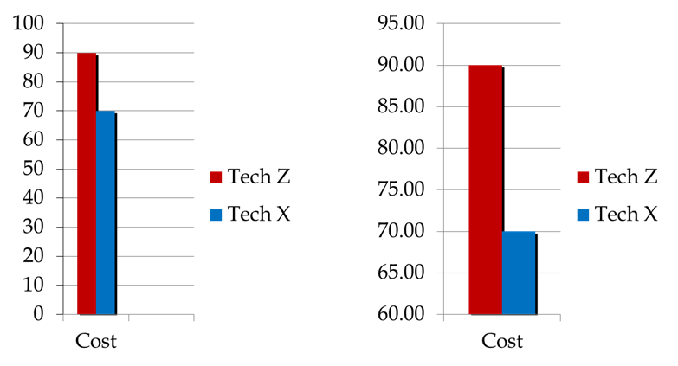
Figure 1. Distorting the truth with different scales
Graphics are also helpful in breaking up large blocks of text and encourage the reader to focus on the key points you want to highlight.
When you use graphics, make sure your images follow these guidelines:
- Have a consistent size and shape
- Have an explanatory caption (like I did in Figure 1)
- Position them correctly on the page, usually after your refer to them (an make sure you refer to them).
- Make sure they are cropped correctly so ‘noise’ and clutter is removed from the screenshot
- Do not allow them to distract the reader from the main text
How do I Structure My White Paper?
Every white paper should have the following sections:
- An Introduction - this opening section covers the high-level issues and trends in cyber-crime that you are involved with. It may also include recommendations or conclusions you have made about the topic.
- A High Level Solution - this describes the relevant information at a high-level, especially the information intend to promote, like the key indicators of an imminent attack. Support your arguments with tables, charts, and graphics. All of these add weight to your argument and provide a contrast to the main text.
- Provide Solution Details - this explains how the attack indicators or threat detection model works. This is the heart of the white paper. It provides very detailed descriptions of the proposed solution. You can also use tables, charts, and graphics for this section, with cross-references to external supporting documents if required.
- A Solution Benefits - This discusses a metric like, usability, defensibility, reliability and adherence to standards. It demonstrates that you are an authority in your field and can back it up with how to use your analysis.
- A Summary - close the paper with a concise summary of your main points. As many readers will skip the entire document and read this section only, summarize the main selling points about your solution here.
Here is a suggestion: write the summary as if it were an entirely standalone document. Distil it into one page and conclude with the most important point that you want the reader to remember. If this section is compelling enough, you might persuade them to go back and read the entire document.
Another suggestion: This summary is often the first part of your documents and is referred to as an Executive Summary.
Conclusion
Remember that your white paper is a sales document not a technical guide. Wait, what are we selling? We are selling a solution to a problem that if not “bought” might leave our organization or our country vulnerable. Once you have finished it, leave it aside for a few days. Then go back and read it.
Key: Ask yourself, “would I buy this solution?”
If you would not, do not be too hard on yourself as it takes time to write a persuasive white paper. Instead, identify the areas you feel are weak and strengthen these. Soon, you will have a nice, sharp document that you can share with your clients.

